**Technical Design Report**

A line break

Trick question Inc. - Reverse Geocaching Box Development





**Embedded Systems Engineering Academy Engineering and Automotive HAN University of Applied Sciences**

**Authors**  
2158469 Federico Giovanni Accossato  
2153089 Henri Krinke  
2140725 Jabez Impano  
2158363 Mohammed Alkhomaish Hernandez  
2156231 Pedro von Sydow

**Tutor**

Remko Welling

**Customer**

Hugo Arends

**Date**

March 2025

**Version**

0.5

# Revisions

|  |  |  |  |
| --- | --- | --- | --- |
| Version | When | Who | What |
|  |  |  |  |
|  |  |  |  |
|  |  |  |  |
|  |  |  |  |
|  |  |  |  |
|  |  |  |  |

# Table of contents

Revisions 1

Table of contents 2

1. Introduction 4

1.1 Background 4

1.2 Reason 4

1.3 Report Structure 4

2 Architecture 5

3 Interfaces 5

3.1 Power supply 5

3.2 Microcontroller – UART – GPS module 5

Specifications: 5

Sequence diagram: 6

3.3 Microcontroller – Color sensor 6

3.4 Microcontroller – Tilt sensor 7

3.5 Microcontroller – Temperature sensor 7

3.6 Microcontroller – Joystick 7

Overview 7

Working Principle 8

Specifications 8

Sequence Diagram: 8

3.7 Microcontroller – LCD-Display 9

3.8 Microcontroller – Buttons 9

3.9 Microcontroller – SD Card 9

3.10 Microcontroller – MOSFET – Solenoid 9

Specifications: 10

Sequence Diagram: 10

4 Software 10

# Introduction

The Technical Design of the Reverse Geocaching Box defines the specific planning of how to implement the functional and technical specifications considering the teams preliminary research on suitable components.

## Background

This document is part of the development process for a Reverse Geocaching Box, which is an interactive system that integrates GPS tracking and puzzle-solving elements to create a fun user experience. Unlike traditional geocaching, where users locate a hidden object using GPS coordinates, this system requires players to solve a series of challenges before unlocking the box they brought with them.

## Reason

The purpose of this document is to outline the technical solutions for implementing the Reverse Geocaching Box. The technical design ensures that the system is not only functional but also reliable and meets the client's expectations. This section defines the integration of hardware components such as the GPS module, joystick, sensors, and solenoid lock, along with the software structure for handling data, user interactions, and overall system management.

By breaking down the system into its individual components and specifying their roles, this document offers a clear technical roadmap to guide development. It details the communication protocols, power supply considerations, and how the system will respond to user inputs, making it an essential part of the project's technical development.

## Report Structure

This section of the report focuses on the **Technical Design** of the Reverse Geocaching Box and is organized into the following key areas:

* **System Architecture**: Overview of the entire system, including hardware and software components, their interactions, and data flow.
* **Interfaces**: Describes the communication between different components, such as the microcontroller and peripheral devices (e.g., GPS module, joystick, sensors, solenoid).
* **Software**: Outlines the style of software being used and shows the structure of the main program

# Architecture

### Architecture diagram:

The Architecture diagram describes how the components will interface with each other. The respective communication types and protocols are noted below the connection in red. The Voltage connections will be specified more in the wiring diagram.

Figure 1: Architecture Diagram

### Wiring diagram:

This diagram show which connections are needed through the colour of the wires, which are assorted a specific kind of connection like RX in the guide on the bottom right. Especially the voltage regulation will be further defined in the realization phase. Additionally, research into the SPI interface for the MicroSD-Card is still being conducted leading to the absence of connections other than voltage.

Figure 2: Wiring Diagram

# Interfaces

## Power supply

## Microcontroller – UART – GPS module

According to F2 of the functional specifications the box needs to track its own position and as can be seen in T2 of the technical specifications (add refence to our functional design doc) the client requires the module for that to be the ATGM336H.

### Working principle

This module uses trilateration, a calculation using the distance to satellites and their positional data to eliminate down to one possible location. These factors are acquired by the patch antenna connected to the module. The coordinates as well as additional information like altitude are communicated to the microcontroller using a UART interface. They are sent in form of a NMEA sentence(add reference to NMEA) made of ASCII characters. The important information in a NMEA sentence is separated by commas.

### Specifications

* The module acquires positional data from satellites and transmits it to the microcontroller every second with an accuracy of a 10m radius around the box.
* The communication uses the lpuart2 peripheral of the FRDM-MXCA153 board and is set to a baud rate of 9600 bits per second with one stop bit and no parity to match the GPS modules specification that can be found in its datasheet (add reference here).
* It needs an RX and a TX pin

### Sequence diagram:

The software for receiving positional data is interrupt based. First an initialization of the lpuart2 peripheral, which was chosen because of it having pin headers on top of the board as documented in the exploratory research document (add reference to that once its done), takes place. This includes the set-up of its interrupt request handler for receiving data. As soon as that is triggered by the module sending processed and formatted data byte by byte the microcontroller puts it in a queue. After that it gets moved from this queue to a buffer which can then be parsed.

Figure 3: Sequence diagram of the GPS module interface

## Microcontroller – Color sensor

### Overview

According to functional specifications F3.3, the Reverse Geocaching Box must include a color-dependent puzzle at one of its locations. Specifically, as detailed in F3.3.1, the puzzle involves detecting different colors presented by the user, each triggering distinct hints or information related to navigating toward the next target location. The module chosen for that was the TCS34725 due to previous experience with the I2C interface.

### Working Principle

The color sensor used is the TCS34725, which operates by measuring the intensity of reflected red, green, blue, and clear (unfiltered) light from an illuminated surface using an integrated IR blocking filter and two built-in LEDs. The sensor communicates with the microcontroller via the I2C communication protocol.

### Specifications

* Interface: I2C communication
* Operating Voltage: 3.3V (compatible with FRDM-MXCA153 microcontroller)
* Operating principle: RGB digital output with using a sensor with integrated IR filter and LED illumination

### TCS34725 Color Sensor Sequence Diagram

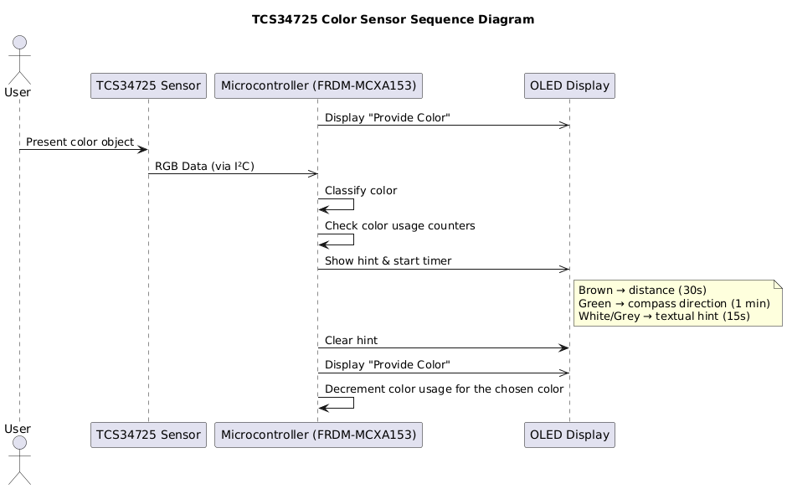

Figure 4: Sequence diagram of the color sensor

## Microcontroller – Tilt sensor

### Overview

The -module has been chosen to fulfil F of the functional specifications. Since it only detects tilts on one axis two modules will be placed in a 90-degree angle to each other.

### Working principle

The module is based on 2 balls in a tube. Once the module is tilted far enough the balls connect which leads to them conducting current. While the current is flowing the module sends a signal to the microcontroller.

### Specifications

* Detects tilt on one axis
* Only needs 1 GPIO

### Sequence diagram

## Microcontroller – Temperature sensor

## Microcontroller – Joystick

### Overview

According to F3.2 of the functional specifications, the geocache box must include a memory game at one of the locations. As specified in F3.2.1 and F3.2.2, (insert reference here) the game involves displaying a sequence of arrows on a screen, which the player must replicate using a joystick.

The joystick serves as the primary input device for user interaction. It is u

sed to navigate through menus, replicate puzzle sequences, and confirm selections. The FRDM-MXCA153microcontroller is responsible for reading joystick inputs and processing them accordingly.

### Working Principle

The joystick is an analog input device that measures movement along two axes (X and Y) and includes a button for selections. The microcontroller reads these inputs and determines the user’s intended actions.

### Specifications

* The joystick operates on two analog axes (X and Y) and one digital button (SW)
* The joystick position is read via the ADC (Analog-to-Digital Converter) of the FRDM-MXCA153 microcontroller
* The joystick button (SW) is connected to a GPIO digital input

### Sequence Diagram:

The joystick input is handled using interrupts, allowing for quick response times and minimal processing delay. Movements are detected through ADC readings, while button presses trigger GPIO interrupts.

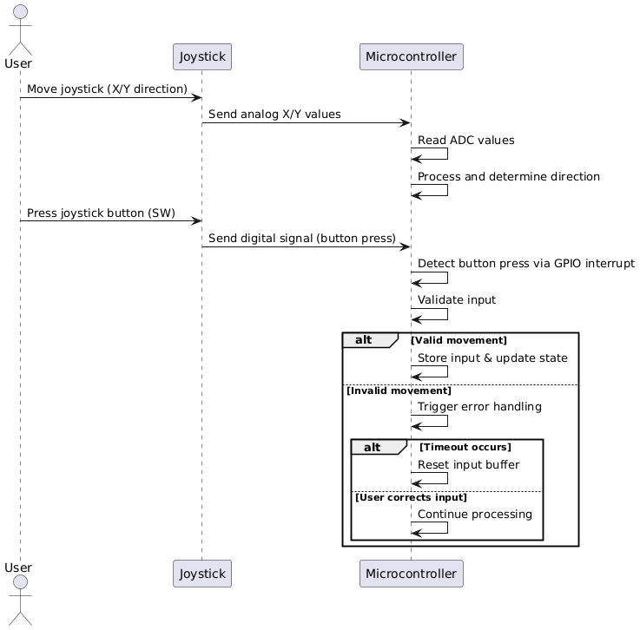

Figure 5: Sequence diagram of the Joystick module interface

## Microcontroller – LCD-Display

### Overview

The LCD-Display works to display the information that we as the builders have specified whether it be the puzzles or relevant information that is used for the game

### Working principle

## Microcontroller – Numpad

## Microcontroller – SD Card

### Overview

The Reverse Geocaching Box must log certain information—such as GPS coordinates (F5.1), temperature (F5.2), and puzzle progress (F5.3)—in persistent memory that can be accessed even when the power is disconnected. To fulfill this requirement, an SD card is used. The microcontroller (FRDM-MCXA153) will communicate with a microSD module via the Serial Peripheral Interface (SPI) bus, storing all log data and allowing retrieval when the box is connected to a companion laptop application.

### Working Principle

## Microcontroller – MOSFET – Solenoid

### Overview

In F1.1 and F1.1.2 of the functional design (insert reference here) it is specified that an actuator must be used to lock and unlock the box, the chosen component is the JF-0530B Solenoid. It was chosen as its pin being pushed out by a spring in its default state leads to it not needing to get powered constantly. Additionally, it is simple to control with a MOSFET since it is voltage controlled. For that the IRLZ34n MOSFET has been chosen since its datasheet matches the needs in terms of gate threshold voltage and source-drain breakdown levels.

### Working principle:

The solenoid works by using the principles of electromagnetism. Inside the solenoid there is a coil around a ferromagnetic object. If this coil has current flowing through it, it creates a magnetic field. The field’s strength is proportional to the current flowing through it and the amount of loops the coil has. This field will pull in the pin of the solenoid.

### Specifications

* Generates a strong enough magnetic field to pull the pin back at 1A, but a current of 300mA is enough to hold it in its position.
* The MOSFET needs to be able to be controlled with logic level voltage between 1.7V to 3.6V and needs to be able to handle 6V of source-drain voltage and 1A source-drain current while leaking less than 300mA of current.
* It needs one GPIO pin set to digital output.

### Sequence Diagram:

The control is done using one GPIO pin which is connected to the gate. When it is set to HIGH, its output is between 1.7V to 3.3V which is enough to activate the gate and let the 6V and 1A through to the solenoid. Once it is cleared and thereby set to LOW again the gate is in the cutoff region not letting any current through or Voltage over since the connection will no longer be grounded.

# Software

The software is designed in a cyclic executive way with interrupts handling events. First the needed peripherals needed for the components as well as for the smooth operating of the software are initialized including interrupt handlers. Then the main loop starts in which the changeable settings like target locations get initialized for this run. Then it goes through the games taking their nature into account of whether they start once a location is reached or whether their point is to reach a certain location. Once the games are solved the code to unlock the box is executed and it will start the laptop communication After that has been successfully finished the main loop repeats and initializes the now potentially changed settings. The interrupts mainly play a role for the game and display functions but for example the reset button uses a pin interrupt routine.

